“Process Tree Visualizer: A Real-Time Display of the Linux Process Hierarchy”
A Project Report Submitted in the partial fulfillment of the requirements for the award of the degree of

BACHELOR OF TECHNOLOGY
In

DEPARTMENT OF COMPUTER SCIENCE ENGINNERING

By

Mokshitha 2520030396

Chandrika 2520030047

Hasini 2520030287

Under the Esteemed Guidance of

Dr. K. Anusha
Assistant Professor
Department of Computer Science and Engineering




K L (Deemed to be) University DEPARTMENT OF COMPUTER SCIENCE ENGINEERING
&

DEPARTMENT OF COMPUTER SCIENCE AND INFORMATION TECHNOL

Declaration

The Project Report entitled “Process Tree Visualizer: A Real-Time Display of the Linux Process Hierarchy” is a record of Bonafide work of 2520030396 Mokshitha
2520030047- Chandrika, 2520030287 Hasini submitted inpartial fulfillment for the award of B. Tech in Computer Science and Engineering (or) Computer Science and Information Technology to the K L University. The results embodied in this report have not been copied from any other departments/University/Institute.

Mokshitha 2520030396

Chandrika 2520030047

S. Hasini 2520030287

K L (Deemed to be) University

DEPARTMENT OF COMPUTER SCIENCE ENGINEERING

CERTIFICATE

This is certify that the mini project based report entitled “Process Tree Visualizer: A Real-Time Display of the Linux Process Hierarchy” is a bonafide work done and submitted by 2520030396- Mokshitha, 2520030047-Chandrika, 2520030287- Hasini

in partial fulfillment of the requirements for the award of the degree of BACHELOR OF TECHNOLOGY in Department of Computer Science Engineering, K L (Deemed to be University), during the academic year 2026-2027.

Signature of the Guide

Signature of the Course Coordinator Signature of the HOD

ACKNOWLEDGEMENT
The success in this project would not have been possible but for the timely help and guidance rendered by many people. Our wish to express my sincere thanks to all those who has assisted us in one way or the other for the completion of my project.

Our greatest appreciation to my Course Coordinator Dr. K. Anusha, and my guide Dr. K. Anusha, Department of Computer Science which cannot be expressed in words for his/her tremendous support, encouragement and guidance for this project.

We express our gratitude to Dr. P Venkateshwara Roa (CSE), Head of the Department for Computer Science Engineering for providing us with adequate facilities, ways and means by which we are able to complete this project-based Lab.

We thank all the members of teaching and non-teaching staff members, and also who have assisted me directly or indirectly for successful completion of this project. Finally, I sincerely thank my parents, friends and classmates for their kind help and cooperation during my work.

Mokshitha 2520030396

Chandrika 2520030047

S.Hasini 2520030287
Abstract

Understanding how an operating system organises running programs is one of the core skills of systems programming, yet standard tools such as ps and top hide how their data is obtained. This project, the Linux Process Tree Visualizer (ptree), is a terminal tool written in C for Ubuntu/Linux that displays the hierarchy of running processes and their parent-child relationships in real time. Its aim is to build the tool from first principles, using only system calls and the /proc file system, with no external libraries.

The core of the tool reads the name, state, parent PID, owner, resident memory and thread count of every process from /proc, sorts the processes by PID, finds each parent by binary search, and links the processes into first-child/next-sibling lists in O(n log n) time. A depth-first walk then draws the tree with colour-coded states. The live viewer refreshes at a configurable interval, marks processes that appeared with a green plus sign, lists those that exited, can be limited to a subtree, a depth or without kernel threads, and is controlled while running through the signals SIGUSR1 and SIGUSR2.

In addition, six modules, one for each course outcome, use the tool's own processes as live experiments: the layered operating system and the cost of system calls (CO1); fork, exec, wait, zombie and orphan processes (CO2); pipes, FIFOs, signals, shared memory and sockets (CO3); demand paging, address translation, copy-on-write and memory protection (CO4); inodes, links, file I/O and a binary snapshot format (CO5); and race conditions, mutexes, condition variables, semaphores and deadlock (CO6). All results are measured on the running machine. The project therefore serves both as a practical process viewer and as a laboratory for the central concepts of an operating-systems course.

Index

S. No. | Chapter | Topics / Subtopics | Page No.
 | Acknowledgement |  | i
 | Abstract |  | ii
1 | Introduction |  | 8–9
 |  | 1.1 Background of the Project
 |  | 1.2 Problem Statement
 |  | 1.3 Scope of the Project
 |  | 1.4 Objectives of the Project
 |  | 1.5 Importance of the Application
 |  | 1.6 Target Users / Audience
2 | OS Concepts and Background Study |  | 10–12
 |  | 2.1 Operating System Concepts Related to the Project
 |  | 2.2 Existing Methods / Algorithms
 |  | 2.3 Proposed Approach
 |  | 2.4 Advantages of the Proposed Approach
3 | System Requirements |  | 13–14
 |  | 3.1 Hardware Requirements
 |  | 3.2 Software Requirements
 |  | 3.3 Operating System Environment – Ubuntu / WSL
 |  | 3.4 Development Tools and Compilers
4 | Technology and Tools Used |  | 15–16
 |  | 4.1 C / C++ Programming
 |  | 4.2 GCC Compiler
 |  | 4.3 Linux System Calls
 |  | 4.4 POSIX Threads / Synchronization
 |  | 4.5 Linux Commands and Utilities
 |  | 4.6 Other Tools / Libraries Used
5 | System Architecture and Design |  | 17–20
 |  | 5.1 Overall System Architecture
 |  | 5.2System Workflow
 |  | 5.3 Flowchart / Data Flow
 |  | 5.4 Module Description
 |  | 5.5 Input and Output Design
6 | Implementation |  | 21–26
 |  | 6.1 Module-wise Implementation
 |  | 6.2 Algorithm / Pseudocode
 |  | 6.3 Core C / C++ Implementation
 |  | 6.4 Linux System Calls / APIs Used
 |  | 6.5 Process / Thread Implementation
 |  | 6.6 IPC / Synchronization Implementation
 |  | 6.7 Memory Management Implementation
 |  | 6.8 Optional User Interface Implementation
7 | Execution and Demonstration |  | 27–37
 |  | 7.1 Compilation in Ubuntu
 |  | 7.2 Execution Commands
 |  | 7.3 Sample Inputs and Outputs
 |  | 7.4 Screenshots of Execution
 |  | 7.5 Demonstration of OS Concepts
8 | Conclusion |  | 38–39
 |  | 8.1 Summary of the Project
 |  | 8.2 Objectives Achieved
 |  | 8.3 Results Achieved
 |  | 8.4 Skills and Learning Outcomes
9 | References |  | 40–41
 |  | 9.1 Books
 |  | 9.2 Research Papers
 |  | 9.3 Linux / GNU Documentation
 |  | 9.4 Online Resources

CHAPTER - 1 INTRODUCTION

1.1 Background of the Project
Every program that runs on a Linux system executes inside a process. A process is created by another process through the fork() system call, so at any moment the running processes form a tree: the first process (PID 1, usually systemd or init) is the root, every login shell is a child of a terminal or login service, every command typed in that shell is a child of the shell, and so on. The kernel records the parent of every process as its PPID (parent process ID), and this single number is enough to rebuild the whole hierarchy.
Understanding this hierarchy is one of the central ideas of an Operating Systems course. It explains why closing a terminal ends the programs started from it, why a crashed program can leave a "zombie" entry behind, why a background daemon is adopted by PID 1 when its launcher exits, and how signals such as Ctrl+C reach a whole group of related processes. Existing commands such as ps, pstree and top show this information, but they treat the kernel as a black box. This project builds the visualizer from first principles, in C, using only system calls and the /proc file system, so that every step between the kernel and the picture on the screen is visible and explainable.
The project, called ptree, is a terminal program for Ubuntu/Linux with no graphical interface and no external libraries. Besides the live tree viewer, it contains one runnable demonstration module for each of the six course outcomes (CO1 to CO6) of the course Operating Systems and Systems Programming (25CS2104E). Each demonstration uses ptree's own processes as the worked example, so the tool is both a useful utility and a teaching aid.

1.2 Problem Statement
Create a tool that displays the hierarchy of running processes and their parent-child relationships in real time. The tool must obtain its data directly from the operating system, must keep the display up to date as processes are created and terminated, and must demonstrate the operating-system concepts (system calls, process control, inter-process communication, virtual memory, file systems and concurrency) that are involved in building such a tool.

1.3 Scope of the Project
- In scope: a live, colour-coded process tree that refreshes at a configurable interval; one-shot printing; filtering by subtree (-p), depth (-d) and kernel threads (-k); detection and highlighting of new and exited processes; control of the running viewer through signals.
- In scope: six course-outcome modules, each with a self-checking demonstration that prints measured results from the running machine: layered OS and system calls (CO1), fork/exec/wait/exit with zombie and orphan processes (CO2), pipes, FIFOs, signals, shared memory and UNIX sockets (CO3), demand paging, address translation, page faults and copy-on-write (CO4), inodes, links, file I/O and a binary snapshot format (CO5), threads, mutexes, condition variables, semaphores, race conditions and deadlock (CO6).
- Out of scope: a graphical user interface, remote monitoring over a network, historical logging, and support for operating systems other than Linux (the tool depends on /proc).

1.4 Objectives of the Project
- To read process information (name, state, PID, PPID, owner, memory, thread count) directly from /proc and build the parent-child tree in memory.
- To display the tree in the terminal and refresh it in real time, highlighting processes that appeared or exited since the previous refresh.
- To apply system calls (open, read, fork, execve, wait, pipe, mmap, kill, sigaction and others) rather than hiding them behind high-level libraries.
- To demonstrate every course outcome with a runnable experiment whose output is measured live and not hard-coded.
- To write robust systems code: handle processes that vanish while being read, partial reads and writes, interrupted system calls, and invalid input files.

1.5 Importance of the Application
Process monitoring is a basic skill of system administration, debugging and performance analysis. A developer who can read the process tree can see which service started which helper, find runaway child processes and recognise zombies. For students, the project turns abstract textbook statements ("a zombie is a terminated process whose parent has not called wait") into something that can be observed: ptree creates a real zombie, shows state Z in the tree, reaps it, and shows that the entry has disappeared. The same applies to copy-on-write, deadlock and the other topics, which makes the tool valuable as a practical companion to the theory.

1.6 Target Users / Audience
- Students of operating systems and systems programming who need to see processes, memory and files "from the inside".
- Instructors who need a compact, reproducible set of live demonstrations (the whole suite runs with ./ptree --demo-all).
- Developers and system administrators who want a small, dependency-free process tree viewer that works on any Linux machine, including Ubuntu on WSL.

CHAPTER - 2 OS CONCEPTS AND BACKGROUND STUDY

2.1 Operating System Concepts Related to the Project
The project touches the main areas of a first operating-systems course. Table 2.1 maps each concept to the part of the project where it is used or demonstrated.
CO | Concept | Where it appears in ptree
CORE | Processes, PID/PPID, process states, /proc | proc.c reads /proc/PID/stat and status; viewer.c colours states R, S, D, Z, T
CO1 | Layered OS, user/kernel mode, system calls, the shell | co1_layers.c: one service via libc, raw syscall() and /proc; measured cost of a mode switch; kernel-address protection
CO2 | fork, exec, wait, exit, zombie, orphan | co2_process.c: --spawn, --zombie, --orphan
CO3 | Pipes, FIFOs, signals, shared memory, sockets, process groups | co3_ipc.c: collector/viewer exchange process statistics through each mechanism; main.c uses SIGUSR1/SIGUSR2 to control the live viewer
CO4 | Virtual memory, paging, page faults, copy-on-write, memory protection | co4_memory.c: --mem and --mem-demo (mmap, pagemap, getrusage, fork, SIGSEGV)
CO5 | File system, inodes, links, file descriptors, file I/O system calls | co5_files.c: --files, --fs-demo, --save/--load binary snapshot
CO6 | Threads, race conditions, mutex, condition variable, semaphore, deadlock | co6_threads.c: --race-demo, --threads, --deadlock-demo

Processes and the process tree. A process is a program in execution together with its resources. The kernel keeps a process descriptor for each one; Linux exposes a read-only view of these descriptors as numbered directories under /proc. fork() duplicates the calling process, execve() replaces its program image, wait() lets the parent collect the exit status, and exit() ends the process. Because each new process records its creator, the set of processes is naturally a tree.
Process states. A process is Running (R), Sleeping (S, waiting for an event), in uninterruptible disk wait (D), Stopped (T, by a signal such as SIGSTOP), or Zombie (Z, terminated but not yet reaped). Modern kernels also report Idle (I) for kernel worker threads. The viewer shows the state letter and name for every process.
System calls and protection. User programs cannot touch hardware or kernel memory directly. They request services through system calls, which switch the CPU from user mode to kernel mode. This switch is much more expensive than an ordinary function call, which CO1 measures live.
Virtual memory. Each process has its own virtual address space, divided into pages (4096 bytes on x86-64). The MMU translates virtual pages to physical frames through page tables; a page that is not yet present causes a page fault that the kernel handles. fork() uses copy-on-write: parent and child share frames until one of them writes. CO4 observes all of these effects on a real process.
Concurrency. Threads of one process share memory, so unsynchronised updates are lost (a race condition). Mutexes give mutual exclusion; condition variables let threads sleep until a condition holds; counting semaphores limit the number of simultaneous users of a resource. If threads acquire locks in opposite orders they can deadlock. CO6 reproduces each situation.

2.2 Existing Methods / Algorithms
Tool | What it does | Limitation for learning
ps (ps -ef --forest) | Prints a snapshot of processes; --forest draws an ASCII tree | One-shot only; no live refresh or change highlighting
pstree | Compact tree of all processes | Static; hides state, memory and thread count by default
top / htop | Live, sorted process list (htop has a tree mode) | Large programs with many dependencies; the code does not show how the data is obtained
/proc browsing by hand | cat /proc/PID/stat | Raw fields; the tree has to be assembled manually

All of these read the same source, /proc. The classical algorithm for building the tree is: (1) list every numeric directory in /proc; (2) read the PPID of each process; (3) group processes by PPID; (4) walk the groups from the root. A naive implementation searches the whole list for each parent and therefore costs O(n squared) for n processes.

2.3 Proposed Approach
ptree follows the same four steps but organises the data for speed and robustness:
- Snapshot. Every numeric directory in /proc is read once into a dynamic array of Proc records (pid, ppid, name, state, owner, resident memory, threads).
- Sort and search. The array is sorted by PID with qsort(); each process then finds its parent by binary search, so building all links costs O(n log n) instead of O(n squared).
- First-child / next-sibling lists. Every record stores the array index of its first child and next sibling. This needs no extra allocation and keeps children ordered by PID.
- Depth-first rendering. A recursive walk prints each node with the branch symbols and carries the correct indentation prefix to children.
- Differencing. The previous snapshot is kept; PIDs missing from it are marked new and PIDs that are missing from the current one are listed as exited.
- Tolerance to races. A process can exit while it is being read. read_process() returns -1 in that case and the process is silently skipped instead of aborting the scan.

2.4 Advantages of the Proposed Approach
- Written in plain C with no dependencies, so it builds with a single make on any Ubuntu/WSL installation and needs no sudo.
- Efficient: O(n log n) tree construction, one pass over /proc per refresh, no external processes spawned.
- Correct on difficult data: process names that contain spaces or parentheses are parsed by locating the first "(" and the last ")" of /proc/PID/stat.
- Transparent: each OS concept is exercised by real system calls and the results are printed, so the program doubles as a lab manual.
- Interactive without a GUI: refresh interval, filters and signals (SIGUSR1, SIGUSR2) control the live view.

CHAPTER - 3 SYSTEM REQUIREMENTS

3.1 Hardware Requirements
Component | Minimum | Recommended
Processor | Any 64-bit x86-64 or ARM64 CPU, 1 core | 2 or more cores (the race condition in CO6 is easiest to observe with at least 2)
Memory (RAM) | 512 MB | 2 GB or more
Disk space | 10 MB for sources and binary | 50 MB (temporary demo files in /tmp are removed automatically)
Display | Any terminal, 80 columns | 120 x 40 terminal with ANSI colour support
Test machine used | Virtual machine, x86-64, 2 CPUs, ext4 root file system

3.2 Software Requirements
Software | Details
Operating system | Ubuntu 22.04 / 24.04 LTS (native, virtual machine or WSL 2). Any Linux with /proc will work.
Compiler | GNU C compiler (gcc) with C11 support. Tested with gcc 13.3.0.
Build tool | GNU Make 4.x. Tested with GNU Make 4.3.
C library | glibc with POSIX threads and POSIX real-time extensions (librt). Tested with glibc 2.39.
Editor / IDE | Visual Studio Code (or any text editor) with its integrated terminal
Optional tools | strace, valgrind, gdb for further experiments suggested by the demos

3.3 Operating System Environment – Ubuntu / WSL
The program reads the Linux /proc pseudo file system and uses Linux-specific features (prctl with PR_SET_CHILD_SUBREAPER, pipe2, /proc/self/pagemap, POSIX shared memory under /dev/shm). It therefore runs on Ubuntu and on Ubuntu under Windows Subsystem for Linux, but not on macOS or native Windows. No administrator rights are needed. Running the memory demo with sudo additionally shows real physical frame numbers, because the kernel hides them from unprivileged users.
Installation steps on Ubuntu:
sudo apt update
sudo apt install build-essential # gcc + make (skip if installed)
unzip process-tree-visualizer.zip
cd process-tree-visualizer
code . # open in VS Code, Ctrl+` for terminal
make # builds ./ptree

3.4 Development Tools and Compilers
The Makefile compiles every file in src/ into build/ with the following flags and links the result into ./ptree:
Flag | Purpose
-Wall -Wextra | Enable almost all compiler warnings; the project builds without warnings
-O2 | Optimise; also makes the CO1 timing loops realistic
-D_GNU_SOURCE | Expose Linux/GNU extensions (pipe2, prctl, timedlock, barriers)
-pthread | Compile and link POSIX threads support
-lrt | Link POSIX real-time library (shm_open, semaphores on older glibc)

Make rebuilds only the files that changed because each object file depends on its source and on the shared header ptree.h. Other useful targets are make run (live viewer), make demo (all demonstrations) and make clean.

CHAPTER - 4 TECHNOLOGY AND TOOLS USED

4.1 C / C++ Programming
The project is written in C (about 2,150 lines in 10 source files, nine .c files and one header, plus a Makefile and a Bash demo script). C was chosen because system calls, structures such as the process record and the 96-byte snapshot record, and manual memory management (malloc, realloc, free) map directly onto what the operating system exposes. Features of C used include structures and typedefs, function pointers (thread entry points), static assertions (_Static_assert checks that the binary file layout has no hidden padding), the volatile and sig_atomic_t types for signal handlers, and C11 atomics (atomic_long) for the lock-free counter.

4.2 GCC Compiler
GCC translates each source file to an object file and the linker combines them with glibc. Compiling with -Wall -Wextra caught issues such as ignored return values of read() and ftruncate(), which are handled explicitly by the IGNORE_RESULT macro or checked. GCC also provides the sanitizers (-fsanitize=address) that the memory demo suggests for further study.

4.3 Linux System Calls
Table 4.1 lists the system calls and kernel interfaces used, grouped by purpose.
Area | System calls / interfaces | Used in
Process control | fork, execvp (execve), waitpid, _exit, getpid, getppid, prctl(PR_SET_CHILD_SUBREAPER) | co2_process.c, all demos
Signals | sigaction, sigprocmask, sigsuspend, kill, pause | main.c, co3_ipc.c
IPC | pipe, pipe2, mkfifo, shm_open, ftruncate, mmap, socket, bind, listen, accept, connect | co3_ipc.c
Process groups | setpgid, getpgrp, getsid, kill(-pgid) | co3_ipc.c
Memory | mmap, munmap, getrusage, sysconf(_SC_PAGESIZE), /proc/self/pagemap | co4_memory.c
Files | open, read, write, lseek, close, fstat, link, symlink, readdir, readlink, msync, /proc/self/mountinfo | co5_files.c, proc.c
Information | uname, ioctl(TIOCGWINSZ), clock_gettime, getpwuid | co1_layers.c, main.c, viewer.c
Raw system call | syscall(SYS_getpid), syscall(SYS_getppid) | co1_layers.c

4.4 POSIX Threads / Synchronization
Module CO6 uses the POSIX threads library: pthread_create and pthread_join for thread lifetime; pthread_mutex_t (lock, unlock, timedlock) for mutual exclusion; pthread_cond_t (wait, signal, broadcast) for waiting until the queue is not empty or not full; sem_t (sem_init, sem_wait, sem_post) as a counting semaphore that limits concurrent /proc readers; and pthread_barrier_t to make the deadlock experiment deterministic. C11 atomic_fetch_add provides the lock-free alternative to the mutex.

4.5 Linux Commands and Utilities
Command | Use in the project
gcc, make | Build the program
./ptree, ./demo.sh | Run the tool and create a changing process tree for the live demonstration
kill -USR1 / -USR2 PID | Refresh the viewer immediately / toggle kernel threads while it runs
ps, pstree, top | Cross-check the output of ptree against standard tools
strace -c / -f | Count and trace the system calls issued by ptree (suggested by CO1)
ls -li, stat, cat /proc/PID/maps | Verify inode numbers, link counts and memory maps shown by CO4 and CO5
valgrind, gdb | Memory-error checking and debugging

4.6 Other Tools / Libraries Used
- /proc (procfs): the kernel interface that is the data source of the whole project: /proc/PID/stat, /proc/PID/status, /proc/PID/statm, /proc/PID/maps, /proc/PID/fd, /proc/self/pagemap.
- ANSI escape sequences: colours and screen control (clear screen, hide/show cursor) without a curses library.
- Visual Studio Code: editor and integrated terminal for development.
- Only the C standard library (glibc) is linked; there are no third-party libraries.

CHAPTER - 5 SYSTEM ARCHITECTURE AND DESIGN

5.1 Overall System Architecture
ptree is a single user-mode program organised into a core and six course-outcome modules. The core (main.c, proc.c, viewer.c) implements the viewer. Each CO module is independent and reuses the core functions (for example viewer_print_subtree() shows the live tree inside every demonstration). All modules talk to the kernel only through the system-call interface.
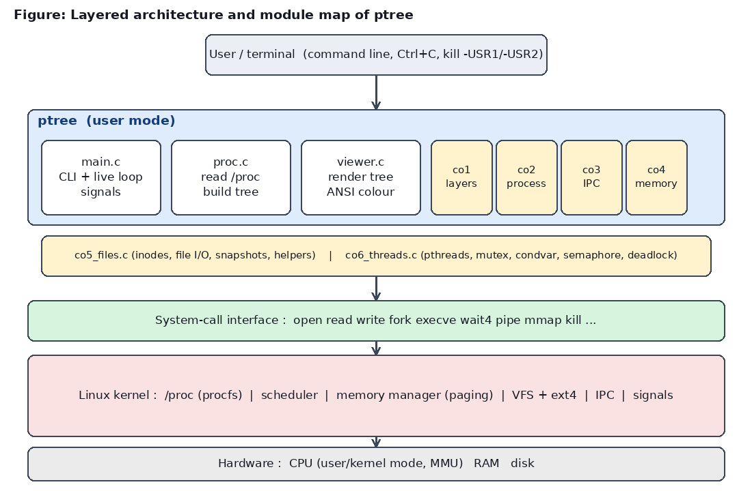
Figure 5.1: Layered architecture and module map of ptree

5.2 System Workflow
The program starts in main(), parses the command line and chooses a mode. In a demonstration mode it calls the matching module and exits. In viewer mode it enters the live loop:
- Install signal handlers: SIGINT and SIGTERM stop the program cleanly, SIGUSR1 requests an immediate refresh and SIGUSR2 toggles the hiding of kernel threads. The handlers only set sig_atomic_t flags; all real work happens in the main loop, which is the safe way to write handlers.
- Load a snapshot of /proc and read the terminal height with ioctl(TIOCGWINSZ).
- Clear the screen, render the tree and print the status line.
- Keep the snapshot as "previous" and sleep for the refresh interval in 100 ms slices. After each slice the flags are checked, so a signal or Ctrl+C is answered within a tenth of a second instead of after the full interval.
- On exit, restore the cursor and free all memory.

5.3 Flowchart / Data Flow
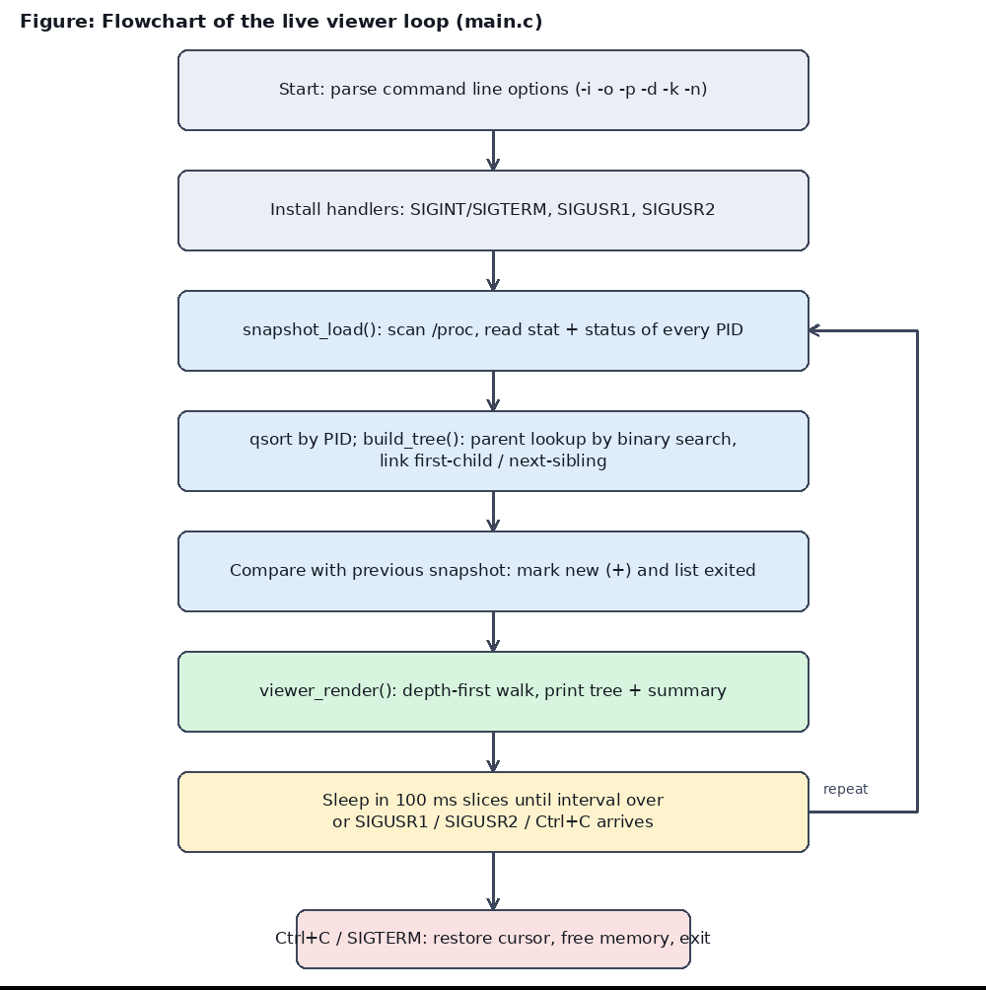
Figure 5.2: Flowchart of the live viewer loop
Data flows in one direction. The kernel produces text in /proc; read_process() parses it into Proc records; snapshot_load() collects them into a Snapshot; build_tree() links them; viewer_render() converts the linked structure to coloured text on standard output. The structure produced by build_tree() is shown in Figure 5.3.
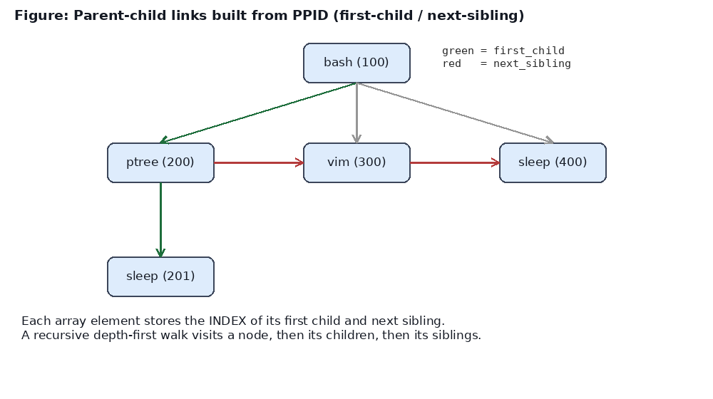
Figure 5.3: Parent-child links built from PPID

5.4 Module Description
File | Lines | Responsibility
ptree.h | 96 | Shared data structures (Proc, Snapshot, Stats, Options) and declarations of every module function
main.c | 208 | Command-line parsing, signal handlers, live refresh loop, dispatch to demo modules, --demo-all
proc.c | 167 | CORE: read_process() parses /proc; snapshot_load(), find_pid() (binary search), build_tree(), snapshot_stats()
viewer.c | 193 | CORE: tree drawing with box characters, colour by state, new (+) markers, Exited list, banners
co1_layers.c | 143 | CO1: layered OS, three routes to one service, mode-switch cost, ancestor chain, kernel-memory protection
co2_process.c | 170 | CO2: --spawn (fork+exec+wait), --zombie, --orphan
co3_ipc.c | 241 | CO3: anonymous pipe, FIFO, signals, process groups, POSIX shared memory, UNIX socket
co4_memory.c | 282 | CO4: address-space map, statm, page faults; demand paging, pagemap translation, copy-on-write, SIGSEGV
co5_files.c | 385 | CO5: FD table and inodes, file I/O demo, snapshot save/load; shared helpers write_full, read_full, safe_fork
co6_threads.c | 261 | CO6: race condition, bounded-buffer scan with mutex/condvars/semaphore, deadlock detection and prevention
demo.sh | 25 | Creates a continuously changing process tree for the live demonstration

Main data structures.
typedef struct {
int pid;
int ppid;
char comm[64]; /* process name */
char state; /* R, S, D, Z, T, I ... */
uid_t uid; /* owner */
long rss_kb; /* resident memory in KB */
long threads; /* number of threads */
int is_new; /* appeared since previous snapshot */
int first_child; /* index of first child, -1 if none */
int next_sibling; /* index of next sibling, -1 if none */
int is_kthread; /* kernel thread (child of kthreadd) */
} Proc;

The Proc record holds everything shown on one line of the tree plus the two link fields. A Snapshot is a growable array of Proc (items, count, capacity). Stats holds the totals shown in the header line, and Options holds the command-line settings.

5.5 Input and Output Design
Input is a command line; there is no interactive prompt. The data input is the /proc file system.
Option | Meaning
(none) | Live view, refresh every second, Ctrl+C to quit
-o | Print the tree once and exit
-i SEC | Refresh interval in seconds
-p PID | Show only the subtree below PID
-d N | Limit depth to N levels
-k | Hide kernel threads (children of kthreadd)
-n | Disable colours (also automatic when output is not a terminal)
--layers, --spawn CMD, --zombie, --orphan, --ipc, --mem [PID], --mem-demo, --files [PID], --fs-demo, --save FILE, --load FILE, --threads, --race-demo, --deadlock-demo, --demo-all | Course-outcome demonstrations (Chapter 7)
kill -USR1 / -USR2 PID | Runtime control of a running viewer

Output is text. The first two lines show the title with the time and the totals (processes, running, sleeping, stopped, zombie, threads). Each following line has the form:
|-- name (PID) [S state-name] owner resident-memory thr:threads

State letters are coloured: green running, grey sleeping, yellow disk wait, red zombie, magenta stopped. A bold green "+" marks a process that appeared since the last refresh, and an "Exited:" line (red) lists up to eight processes that ended. If the terminal is too short, the tail of the tree is replaced by a message such as "... 12 more lines" with advice to use -d, -p or -k.

CHAPTER - 6 IMPLEMENTATION

6.1 Module-wise Implementation
This chapter explains how each module is implemented, with code taken directly from the source files. Every module follows the same pattern: print a banner, run a real experiment with system calls, read the result back from the kernel, and print an explanation.
Core viewer (proc.c, viewer.c, main.c). proc.c turns /proc into data; viewer.c turns data into text; main.c supplies the loop. The modules are described in sections 6.2 and 6.3. CO1 (co1_layers.c) shows the same service (the PID) obtained through glibc getpid(), the raw syscall(SYS_getpid) and open/read/close on /proc/self/stat, times 2,000,000 ordinary function calls against 2,000,000 system calls, prints the chain of ancestors of the running program to show that the shell is an ordinary process, and forks a child that deliberately reads a kernel address to show that the CPU kills it. CO2 (co2_process.c) implements spawn, zombie and orphan. CO3 (co3_ipc.c) implements six IPC mechanisms. CO4 (co4_memory.c) inspects and experiments with memory. CO5 (co5_files.c) works with files and inodes. CO6 (co6_threads.c) creates threads and synchronisation. Details follow in 6.5 to 6.7.

6.2 Algorithm / Pseudocode
Algorithm 1: build the process tree
Input : unsorted array P of n processes with fields pid, ppid
Output: first_child / next_sibling links, list of roots

1. sort P by pid O(n log n)
2. for i = 0 .. n-1: last_child[i] = -1, links = -1
3. for i = 0 .. n-1:
4. parent = binary_search(P, P[i].ppid) O(log n)
5. mark P[i] as kernel thread if pid == 2 or ppid == 2
6. if parent not found or parent == i: add i to roots
7. else if parent has no child yet: P[parent].first_child = i
8. else: P[ last_child[parent] ].next_sibling = i
9. last_child[parent] = i

Total time O(n log n), extra space O(n).

Algorithm 2: draw the tree (depth-first)
print_node(node, prefix, is_last, depth):
print prefix + ("last-branch" if is_last else "branch") + node info
if depth limit reached: return
child_prefix = prefix + (" " if is_last else "| ")
find last visible child (so the final branch is drawn correctly)
for each visible child c in sibling order:
print_node(c, child_prefix, c == last_visible, depth + 1)

Algorithm 3: detect new and exited processes
for each process c in current snapshot: c.is_new = (c.pid not in previous)
for each process q in previous snapshot: if q.pid not in current: add to Exited list
(both lookups use binary search because snapshots are sorted by pid)

6.3 Core C / C++ Implementation
Reading one process. The name in /proc/PID/stat is written inside parentheses and may contain spaces or even parentheses, so the parser takes everything between the first "(" and the last ")". The fields after it are read with one sscanf that skips the unwanted columns and keeps the state, the parent PID and the thread count:
char *lp = strchr(buf, '(');
char *rp = strrchr(buf, ')');
if (!lp || !rp || rp < lp) return -1;
size_t len = (size_t)(rp - lp - 1);
if (len >= sizeof p->comm) len = sizeof p->comm - 1;
memcpy(p->comm, lp + 1, len);
p->comm[len] = '\0';

/* After ")" the fields are: state ppid pgrp session tty_nr tpgid
* flags minflt cminflt majflt cmajflt utime stime cutime cstime
* priority nice num_threads ... */
if (sscanf(rp + 2,
"%c %d %*d %*d %*d %*d %*u %*u %*u %*u %*u %*u %*u %*d %*d %*d %*d %ld",
&p->state, &p->ppid, &p->threads) != 3)
return -1;

The owner and resident memory come from /proc/PID/status (the Uid: and VmRSS: lines). If any open fails because the process has just exited, the function returns -1 and the caller skips the process.
Linking parents and children. build_tree() is the direct implementation of Algorithm 1:
Proc *p = &s->items[i];
int parent = (p->ppid > 0) ? find_pid(s, p->ppid) : -1;

/* kernel thread = pid 2 (kthreadd) or any child of it */
p->is_kthread = (p->pid == 2 || p->ppid == 2);

if (parent < 0 || parent == i) {
roots[(*nroots)++] = i; /* no parent found -> root */
} else if (last_child[parent] < 0) {
s->items[parent].first_child = i;
last_child[parent] = i;
}

Drawing a node. print_node() prints the branch symbol, the new-process marker, the name, PID, coloured state, owner, memory and thread count, then recurses into the children:
printf("%s%s", prefix, is_root ? "" : (is_last ? "`-- " : "|-- "));
if (p->is_new) printf("%s+%s", col(C_BOLD C_GREEN), col(C_RESET));
printf("%s%s%s (%d) ", col(C_BOLD), p->comm, col(C_RESET), p->pid);
printf("%s[%c %s]%s ", col(state_color(p->state)), p->state,
state_name(p->state), col(C_RESET));
printf("%s%s%s %s%s%s thr:%ld\n",
col(C_CYAN), user_of(p->uid, ubuf, sizeof ubuf), col(C_RESET),
col(C_BLUE), mem, col(C_RESET), p->threads);

The live loop. The loop in main.c loads a snapshot, renders it, keeps it as the previous snapshot and then waits in 100 ms slices so signals are noticed quickly:
for (int t = 0; t < g_opt.interval * 10 && g_running && !g_refresh_now && !g_toggle_k; t++)
usleep(100000);

6.4 Linux System Calls / APIs Used
Each demonstration is built around a small number of system calls. The most instructive ones are summarised in Table 6.1.
Module | Key calls | What the call shows
CO1 | getpid(), syscall(SYS_getpid), open/read/close, uname, clock_gettime | Same service at three abstraction levels; nanosecond cost of crossing into the kernel
CO2 | fork, execvp, waitpid, prctl, pipe2(O_CLOEXEC) | Process creation, image replacement, reaping; reporting a failed exec to the parent through a close-on-exec pipe
CO3 | pipe, mkfifo, sigaction, kill, setpgid, shm_open+mmap, socket/bind/listen/accept/connect | One result delivered through six different IPC channels
CO4 | mmap, getrusage, /proc/self/pagemap, fork, sigaction(SA_SIGINFO) | Demand paging, translation, COW, fault address and reason (SEGV_MAPERR / SEGV_ACCERR)
CO5 | open, write, lseek, read, fstat, link, symlink, getdents via readdir, mmap+msync | Inode content, hard versus symbolic link, buffered versus unbuffered I/O
CO6 | pthread_create/join, mutex, cond, sem, barrier, atomic_fetch_add | Race, coordination and deadlock

6.5 Process / Thread Implementation
Process creation (CO2 spawn). The parent creates two pipes. The first, "gate", holds the child back until the parent has printed the tree "right after fork", so the output is deterministic. The second, "err", is created with O_CLOEXEC: if execvp() succeeds the descriptor is closed automatically and the parent reads end-of-file; if exec fails, the child writes errno into the pipe and exits with status 127. The parent therefore knows whether exec worked, which a plain fork/exec cannot tell it.
pid_t pid = safe_fork(); /* 1. create the child */
if (pid < 0) { perror("fork"); return 1; }

if (pid == 0) { /* ---- child ---- */
close(gate[1]);
close(err[0]);
char c;
while (read(gate[0], &c, 1) < 0 && errno == EINTR) { } /* wait for parent's "go" */
close(gate[0]);
execvp(argv[0], argv); /* 2. replace the program image */
int e = errno; /* only reached if exec FAILED */
write_full(err[1], &e, sizeof e);
_exit(127);
}

The parent then prints the tree twice. Right after fork the child is still "ptree" (a copy of the parent); after exec the same PID shows the new program name. Finally waitpid() reaps the child and the exit status is decoded with WIFEXITED/WEXITSTATUS or WIFSIGNALED/WTERMSIG.
Zombie. The child calls _exit(42) immediately and the parent does not call wait for 200 ms. Reading /proc/PID/stat during this time returns state Z; after waitpid() the /proc entry disappears.
Orphan. A middle process A creates a grandchild B and exits. To make the experiment behave identically on every machine, the main process first becomes a "subreaper" with prctl(PR_SET_CHILD_SUBREAPER, 1), so the orphaned B is re-parented to ptree and not to PID 1. The PPID of B is printed before and after.
Threads (CO6 bounded buffer). A producer (the main thread) puts the PIDs found in /proc into a queue of 8 slots; four worker threads take jobs, read the process data and store the result. The shared state is protected by one mutex, two condition variables make threads sleep instead of busy-waiting, and a counting semaphore initialised to 2 allows at most two workers to read /proc at the same time:
static void *scan_worker(void *arg) {
long id = (long)arg;
for (;;) {
pthread_mutex_lock(&g.lock);
while (g.count == 0 && !g.done)
pthread_cond_wait(&g.not_empty, &g.lock); /* sleep until work arrives */
if (g.count == 0 && g.done) { pthread_mutex_unlock(&g.lock); break; }
Job j = g.q[g.head];
g.head = (g.head + 1) % QCAP;
g.count--;
pthread_cond_signal(&g.not_full); /* a slot is free again */
pthread_mutex_unlock(&g.lock);

sem_wait(&g.io_slots); /* at most 2 readers at once */
pthread_mutex_lock(&g.lock);
if (++g.cur_io > g.max_concurrent_io) g.max_concurrent_io = g.cur_io;
pthread_mutex_unlock(&g.lock);

g.ok[j.idx] = (read_process(j.pid, &g.results[j.idx]) == 0);
usleep(200); /* pretend the read is slow */

pthread_mutex_lock(&g.lock);
g.cur_io--;
pthread_mutex_unlock(&g.lock);
sem_post(&g.io_slots);

g.handled[id]++; /* private to this worker */
}
return NULL;
}

6.6 IPC / Synchronization Implementation
The IPC module plays two roles: a "collector" child process gathers statistics (or answers a query) and the "viewer" parent receives them. The same Stats structure (totals of processes by state and number of threads) is sent through different channels:
Mechanism | Implementation | Properties shown
A. Anonymous pipe | pipe(); child writes the Stats structure with write_full(), parent reads it with read_full() | No name; only between related processes
B. Named pipe (FIFO) | mkfifo(/tmp/ptree_demo.fifo); child redirects stdout into it with dup2() and prints the tree; parent copies it to the screen | Has a path in the file system; unrelated processes can use it
C. Signals | sigaction with SA_SIGINFO to learn the sender PID; SIGUSR1 blocked with sigprocmask and waited for with sigsuspend (no lost signal); SIGSTOP/SIGCONT/SIGTERM change the state shown in the tree | Asynchronous; SIGKILL and SIGSTOP cannot be caught
D. Process groups | setpgid() in both parent and child to avoid a race; kill(-pgid, SIGTERM) | A negative PID signals the whole group (how Ctrl+C reaches a job)
E. Shared memory | shm_open + ftruncate + mmap(MAP_SHARED); child writes a Stats structure directly into the mapping | Fastest IPC; no copy; needs synchronisation (here waitpid)
F. UNIX domain socket | socket/bind/listen in the parent, accept in the child; protocol "WHO <pid>" returns name, parent and state | Two-way; address is a file path

The same techniques are used inside the real tool: the live viewer is controlled by SIGUSR1 and SIGUSR2 and handles SIGINT and SIGTERM. The handlers set flags only, as required for async-signal-safe code.
Synchronisation experiments (CO6). The race demonstration starts 4 threads that each add 1 to a shared counter one million times, in three variants: an unprotected volatile long, a counter protected by a mutex, and an atomic counter. The unprotected variant loses updates because counter = counter + 1 is a load, an add and a store. The deadlock demonstration makes two threads take two mutexes A and B in opposite order. A plain pthread_mutex_lock would hang, so the program uses pthread_mutex_timedlock with a one-second timeout to detect the circular wait, then repeats the run with both threads taking A before B to show that ordering the locks removes the deadlock.

6.7 Memory Management Implementation
Address-space map (--mem [PID]). The module reads /proc/PID/maps and classifies each region as code, data, heap, stack, shared-library code, anonymous or kernel-provided, summing the sizes. It also reads /proc/PID/statm (virtual size, resident pages and shared pages) and the minor and major page-fault counters.
Demand paging and translation (--mem-demo). The program maps 16 MB with mmap(). The virtual size grows by 16 MB but the resident size grows by 0 KB, because no frame has been allocated. It then writes one byte into each of the first 2048 pages and measures the minor page faults with getrusage(); there is one fault per page touched. For each chosen page it reads one 64-bit entry from /proc/self/pagemap at offset (virtual page number x 8). Bit 63 tells whether the page is present and bits 0 to 54 hold the physical frame number; this is the virtual-to-physical translation done by the MMU. (Unprivileged users are told only that the page is present, because the kernel hides frame numbers; running with sudo shows the real frame.)
Copy-on-write. After fork(), the child reads all 2048 shared pages and causes 0 page faults; when it writes to all pages it causes 2048 faults, one copy per page, while the parent's data remains unchanged. This demonstrates both sharing and isolation.
Memory errors. Two children are started on purpose: one writes through a NULL pointer and one writes into a PROT_READ page. A SIGSEGV handler with SA_SIGINFO reads the fault address and the si_code, which distinguishes SEGV_MAPERR (address not mapped) from SEGV_ACCERR (mapped but not permitted). Because the faults occur in children, the main program stays alive and reports how the kernel terminated each child.
Dynamic memory in the core. The Snapshot array starts with 512 entries and doubles with realloc() when full; every allocation is checked and freed, and the live loop frees the previous snapshot on each refresh, so memory use does not grow while the viewer runs.

6.8 Optional User Interface Implementation
The interface is a text user interface made with ANSI escape sequences, without curses. Colour is selected by the state of the process; box-drawing characters show the branches; the cursor is hidden during live mode and restored on exit; the screen is cleared before each frame; and colours are switched off automatically when the output is not a terminal (so ptree -o | less and redirection to files give clean text). The terminal height is read with ioctl(TIOCGWINSZ), and lines that do not fit are summarised instead of scrolling the screen.
File I/O features. --save FILE writes the snapshot as a binary file: a 24-byte header (magic "PTREESNP", version, count, timestamp) followed by 96-byte fixed-size records. _Static_assert statements guarantee the sizes at compile time. --load FILE validates the magic number, version and that the file size equals header size plus count times record size, so a corrupt or truncated file is rejected with a clear message, and then replays the saved tree with the normal renderer.

CHAPTER - 7 EXECUTION AND DEMONSTRATION

7.1 Compilation in Ubuntu
$ sudo apt install build-essential
$ cd process-tree-visualizer
$ make
gcc -Wall -Wextra -O2 -D_GNU_SOURCE -pthread -c src/co1_layers.c -o build/co1_layers.o
... (one line per source file) ...
gcc -o ptree build/co1_layers.o build/co2_process.o ... build/viewer.o -pthread -lrt

The build finishes without errors or warnings. make clean removes the build directory and the binary.

7.2 Execution Commands
Command | Purpose
./ptree | Live tree, refresh every second (Ctrl+C to quit)
./ptree -o | Print the tree once
./ptree -k -d 3 | Hide kernel threads, 3 levels
./ptree -p 1 -i 2 | Subtree of PID 1, refresh every 2 seconds
./ptree --layers | CO1 demonstration
./ptree --spawn sleep 2; --zombie; --orphan | CO2 demonstrations
./ptree --ipc | CO3 demonstration
./ptree --mem [PID]; --mem-demo | CO4 demonstrations
./ptree --files [PID]; --fs-demo; --save f.bin; --load f.bin | CO5 demonstrations
./ptree --race-demo; --threads; --deadlock-demo | CO6 demonstrations
./ptree --demo-all (or make demo) | Run every demonstration in order
./demo.sh (terminal 1) and ./ptree -p PID (terminal 2) | Live demonstration with a changing tree

7.3 Sample Inputs and Outputs
Input: ./ptree -o -p 590 while demo.sh is running (590 is the PID printed by demo.sh). Output:
Linux Process Tree Visualizer 05:10:51
Processes: 75 running:1 sleeping/other:73 stopped:0 zombie:1 threads:106

demo.sh (590) [S sleeping] root 3.2MB thr:1
|-- demo.sh (592) [S sleeping] root 1.8MB thr:1
| |-- sleep (594) [S sleeping] root 1.7MB thr:1
| `-- sleep (595) [S sleeping] root 1.6MB thr:1
|-- demo.sh (593) [S sleeping] root 1.8MB thr:1
| |-- sleep (596) [S sleeping] root 1.7MB thr:1
| `-- demo.sh (597) [S sleeping] root 1.8MB thr:1
| `-- sleep (598) [S sleeping] root 1.7MB thr:1
`-- sleep (599) [S sleeping] root 1.7MB thr:1

The header shows 75 processes and one zombie on the test machine. The demo script creates a permanent branch (a subshell with two sleep processes) and short-lived branches, so the tree changes every few seconds. The line "demo.sh (597) -> sleep (598)" shows a grandchild: a sleep process started by a subshell that was started by demo.sh.
Live refresh with change detection (./ptree -p 590 -i 3). In the second frame processes that were not in the previous frame carry a "+" and the processes that disappeared are listed on the "Exited:" line:
demo.sh (590) [S sleeping] root 3.2MB thr:1
|-- demo.sh (592) [S sleeping] root 1.8MB thr:1
| |-- sleep (594) ... | `-- sleep (595) ...
|-- +demo.sh (606) [S sleeping] root 1.8MB thr:1 <- new
| `-- +sleep (608) [S sleeping] root 1.7MB thr:1 <- new
`-- +sleep (607) [S sleeping] root 1.7MB thr:1 <- new

Exited: demo.sh(593) sleep(596) demo.sh(597) sleep(598) sleep(599)

Timing values in the following sections (nanoseconds, milliseconds, fault counts) are measured live and will differ on other machines; the relationships between them (for example, a system call is much slower than a function call, a mutex is slower than an atomic) stay the same.

7.4 Screenshots of Execution
The screenshots below were captured from the program running on the test machine (Ubuntu 24.04, Linux 6.18, 2 CPUs).
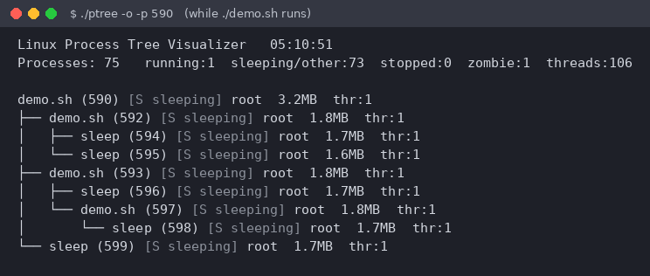
Figure 7.1: Process tree of the demo script (./ptree -o -p 590)
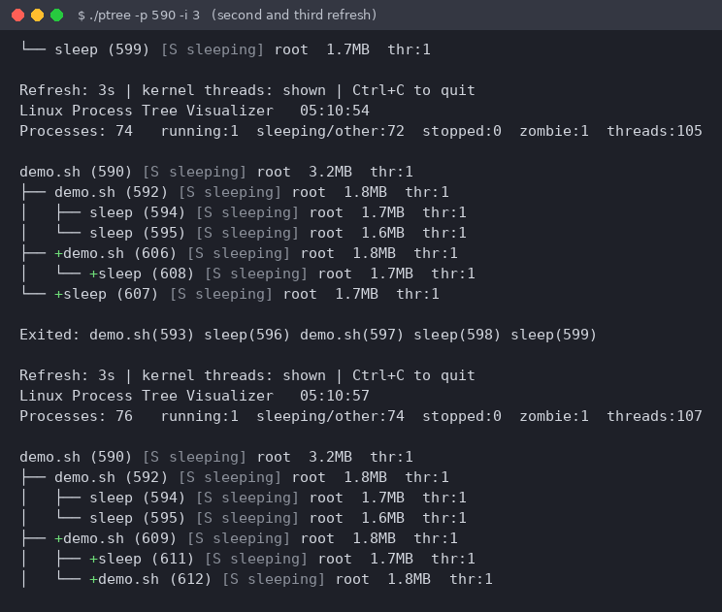
Figure 7.2: Live refresh; "+" marks new processes and the Exited line lists finished ones
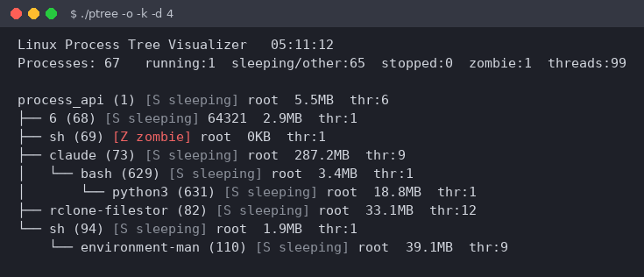
Figure 7.3: Kernel threads hidden (-k) and depth limited to 4 levels (-d 4)
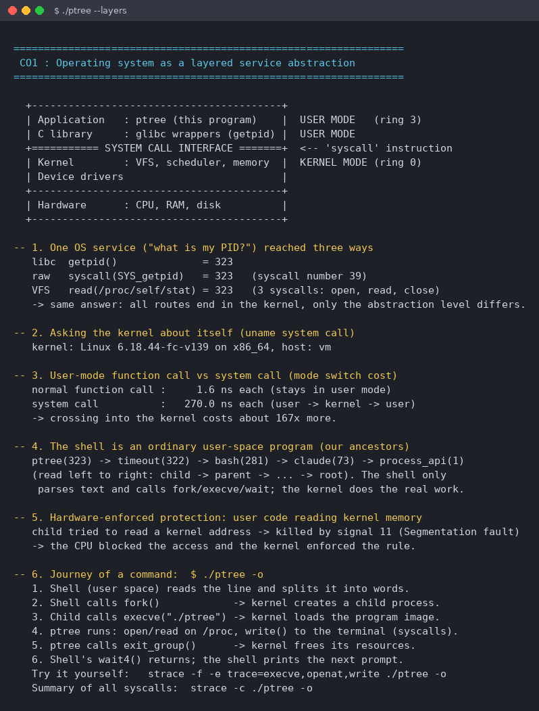
Figure 7.4: CO1 - layered OS, three routes to one service, system-call cost, protection
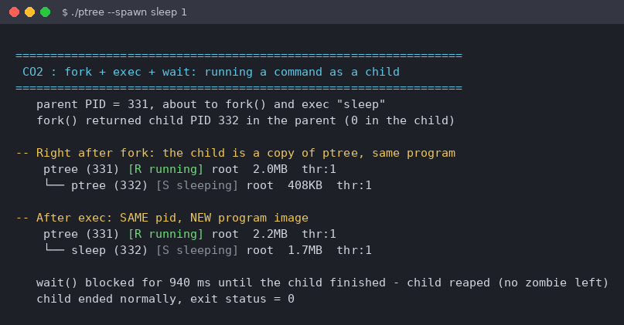
Figure 7.5: CO2 - fork copies the program, exec replaces it (same PID, new image)
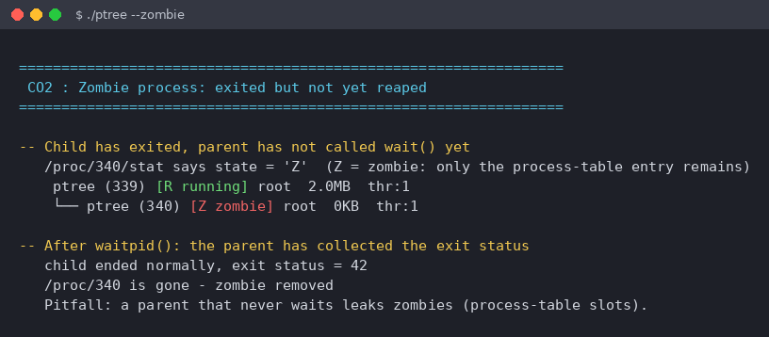
Figure 7.6: CO2 - a real zombie (state Z) and its removal by waitpid()
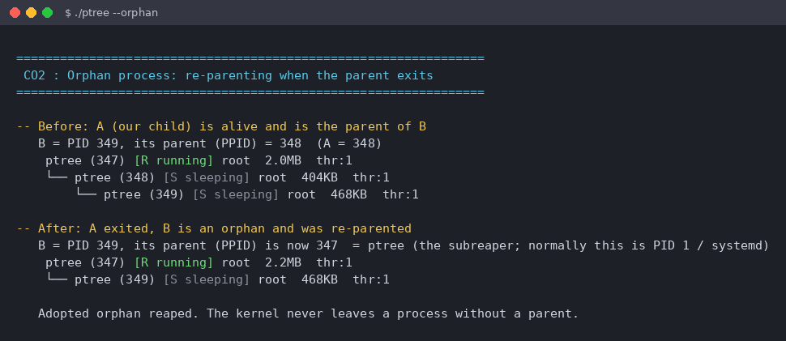
Figure 7.7: CO2 - orphan process re-parented to the subreaper
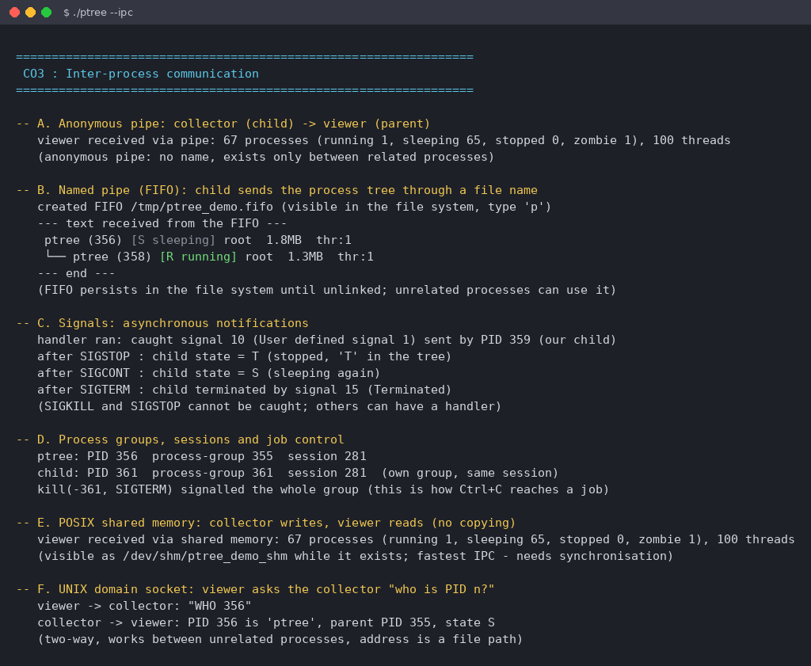
Figure 7.8: CO3 - pipe, FIFO, signals, process groups, shared memory and socket
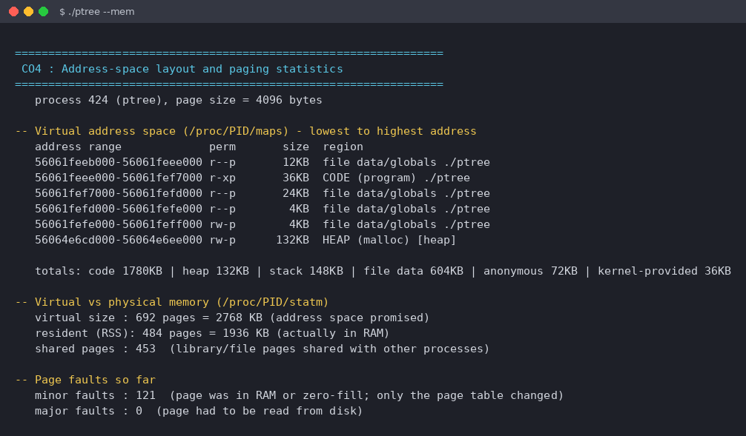
Figure 7.9: CO4 - address-space map of a process (--mem)
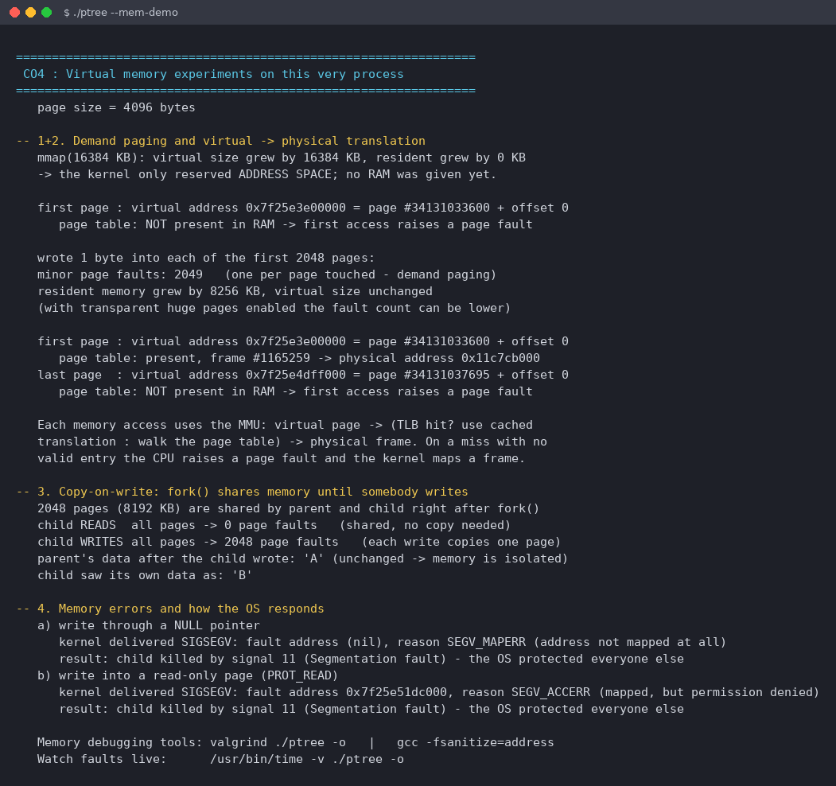
Figure 7.10: CO4 - demand paging, translation, copy-on-write and SIGSEGV
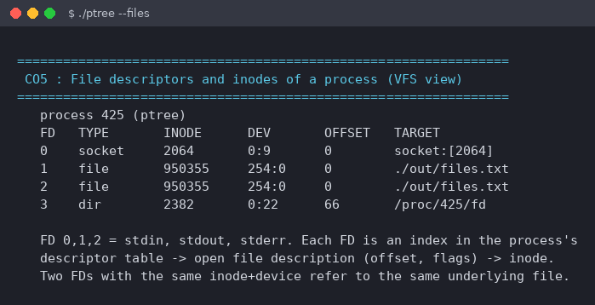
Figure 7.11: CO5 - open file descriptors and their inodes (--files)
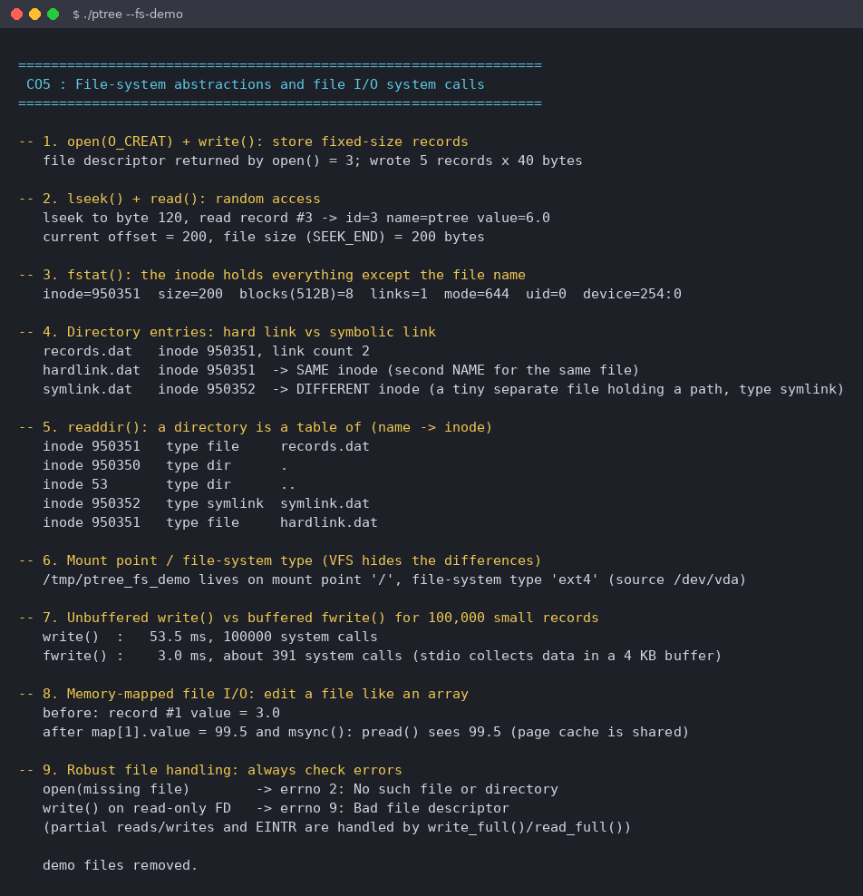
Figure 7.12: CO5 - inodes, links, directory entries, buffered I/O, mmap I/O
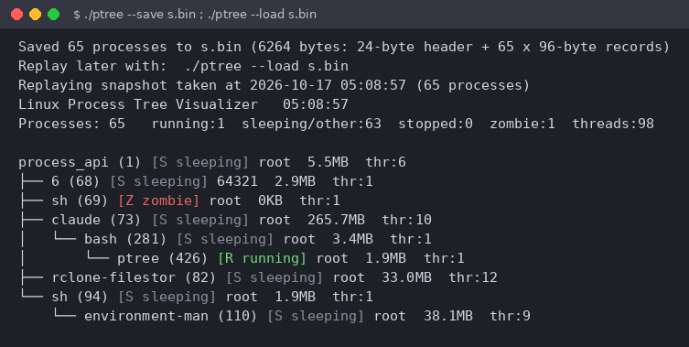
Figure 7.13: CO5 - binary snapshot saved and replayed
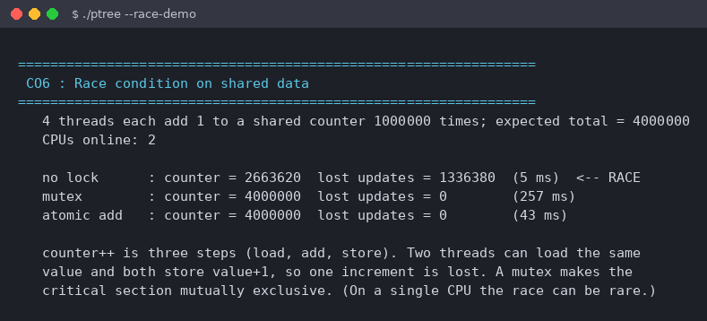
Figure 7.14: CO6 - race condition versus mutex versus atomic
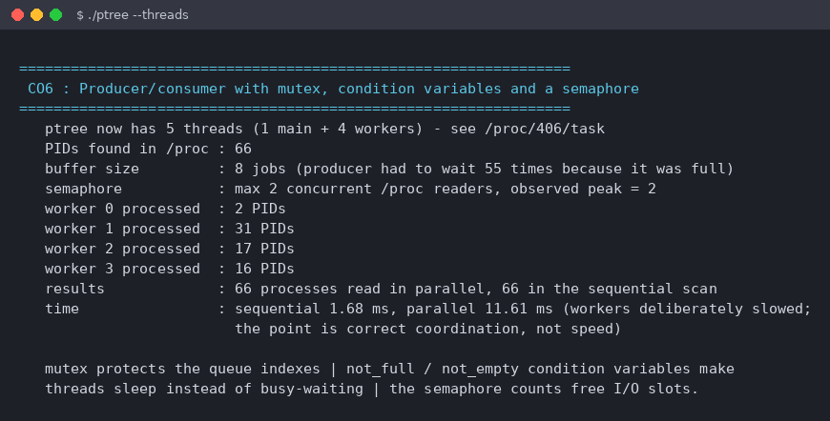
Figure 7.15: CO6 - producer/consumer with mutex, condition variables, semaphore
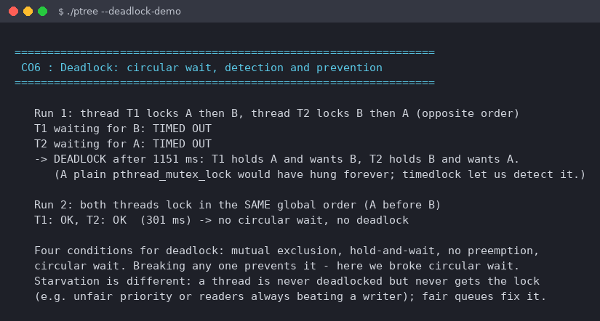
Figure 7.16: CO6 - deadlock detected by timeout and prevented by lock ordering

7.5 Demonstration of OS Concepts
Table 7.1 connects each observation in the screenshots with the concept it demonstrates. The figures are from the run shown above.
CO | Observation | Concept demonstrated
CO1 | getpid(), syscall(SYS_getpid) and read of /proc/self/stat all return the same PID | One kernel service reached at different abstraction levels; all end in the system-call interface
CO1 | Function call about 1.6 ns, system call about 270 ns (about 167 times more) | User-to-kernel mode switch is expensive
CO1 | Child reading a kernel address is killed by signal 11 | Hardware-enforced protection between user and kernel mode
CO1 | Ancestor chain ptree -> timeout -> bash -> ... -> PID 1 | The shell is an ordinary user program that calls fork/exec/wait
CO2 | After fork the child is "ptree"; after exec the same PID is "sleep" | fork duplicates, exec replaces the program image
CO2 | Child state Z until waitpid(); /proc entry then gone | Zombie process and reaping
CO2 | PPID of B changes from A (348) to ptree (347) after A exits | Orphan re-parenting; kernel always gives a process a parent
CO3 | Same statistics (67 processes) arrive via pipe and via shared memory | Different IPC channels; shared memory needs no copy
CO3 | SIGSTOP gives state T, SIGCONT returns to S, SIGTERM ends the child | Signals change process state; kill(-pgid) signals a group
CO4 | mmap of 16 MB: virtual +16384 KB, resident +0 KB; 2049 minor faults for 2048 pages touched | Demand paging; one page fault per first touch
CO4 | Page-table entry changes from "not present" to "present, frame #1165259" | Virtual-to-physical translation
CO4 | Child read: 0 faults, child write: 2048 faults, parent data stays "A" | Copy-on-write and process isolation
CO4 | SEGV_MAPERR for NULL, SEGV_ACCERR for read-only write | Memory protection and fault reporting
CO5 | Hard link has the same inode (950351) with link count 2; symbolic link has its own inode | Inodes, directory entries, link types
CO5 | 100,000 small writes: write() 53.5 ms (100,000 calls) versus fwrite() 3.0 ms (about 391 calls) | Buffered I/O reduces system calls
CO5 | File on mount point "/", type ext4 | VFS hides file-system differences
CO6 | No lock: 2,663,620 of 4,000,000 (1,336,380 updates lost); mutex and atomic: exactly 4,000,000 | Race condition and its two remedies
CO6 | Producer waited 55 times; semaphore peak = 2; 66 PIDs read in parallel and sequentially | Bounded buffer, condition variables, counting semaphore
CO6 | Opposite lock order: both threads time out; same order: both succeed | Deadlock (circular wait) and prevention by lock ordering

CHAPTER - 8 CONCLUSION

8.1 Summary of the Project
The project delivers a Linux Process Tree Visualizer written in C that reads process information directly from /proc, builds the parent-child hierarchy in O(n log n) time, and displays it in the terminal with live refresh, colour-coded states, new-process markers and an exited-process list. The viewer can be filtered and controlled with command-line options and signals. In addition, six course-outcome modules turn the program itself into a laboratory for system calls, process control, IPC, virtual memory, file systems and concurrency.

8.2 Objectives Achieved
Objective | Status
Read process data from /proc and build the tree | Achieved: proc.c, binary search and sibling lists
Real-time display with change detection | Achieved: live loop with +, Exited and signal control
Use system calls directly | Achieved: Table 4.1 lists more than 40 calls and interfaces
Demonstrate every course outcome with live measurements | Achieved: CO1 to CO6 modules, all run by --demo-all
Robust systems code | Achieved: vanishing processes skipped, EINTR and partial I/O handled, file validation, no compiler warnings

8.3 Results Achieved
- The tool builds cleanly with -Wall -Wextra and all demonstrations ran to completion on Ubuntu 24.04 (Linux 6.18, gcc 13.3).
- The tree produced agrees with the parent-child relationships of the running system, including grandchildren created by the demo script.
- The measured results confirm the theory: a system call is about 167 times slower than a function call on the test machine; demand paging causes one fault per page; copy-on-write copies a page only on write; an unprotected counter lost 1,336,380 of 4,000,000 updates; opposite lock order deadlocked and a global lock order did not.
- Memory does not accumulate across refreshes because each snapshot is freed after use.
Limitations and future work. The tool is Linux-only and shows a snapshot sampled every interval, so a process that starts and ends between two samples is not seen. Possible extensions: using the netlink process connector for event-driven updates, keyboard commands (search, kill, sort), CPU-usage columns, and a curses or web front end.

8.4 Skills and Learning Outcomes
- Systems programming in C: structures, pointers, dynamic memory, binary file formats and static assertions.
- Practical use of the process, memory, file and IPC system calls of Linux.
- Multithreaded programming with mutexes, condition variables, semaphores and atomics, and diagnosing races and deadlocks.
- Reading the kernel's own data (/proc, pagemap) to verify OS concepts by measurement.
- Writing signal-safe handlers, robust I/O loops and defensive code against races with the rest of the system.
- Using make, gcc warnings, Linux tools (strace, ps, pstree) and VS Code for development and documentation.

CHAPTER - 9 REFERENCES

9.1 Books
- A. Silberschatz, P. B. Galvin and G. Gagne, Operating System Concepts, 10th ed., Wiley, 2018.
- A. S. Tanenbaum and H. Bos, Modern Operating Systems, 4th ed., Pearson, 2014.
- W. R. Stevens and S. A. Rago, Advanced Programming in the UNIX Environment, 3rd ed., Addison-Wesley, 2013.
- M. Kerrisk, The Linux Programming Interface, No Starch Press, 2010.
- R. Love, Linux Kernel Development, 3rd ed., Addison-Wesley, 2010.
- R. H. Arpaci-Dusseau and A. C. Arpaci-Dusseau, Operating Systems: Three Easy Pieces, Arpaci-Dusseau Books, 2018.
- B. W. Kernighan and D. M. Ritchie, The C Programming Language, 2nd ed., Prentice Hall, 1988.

9.2 Research Papers
- D. M. Ritchie and K. Thompson, "The UNIX Time-Sharing System," Communications of the ACM, vol. 17, no. 7, pp. 365-375, 1974.
- E. G. Coffman, M. J. Elphick and A. Shoshani, "System Deadlocks," ACM Computing Surveys, vol. 3, no. 2, pp. 67-78, 1971.
- P. J. Denning, "Virtual Memory," ACM Computing Surveys, vol. 2, no. 3, pp. 153-189, 1970.
- E. W. Dijkstra, "Cooperating Sequential Processes," Technical report EWD-123, Technological University Eindhoven, 1965.
- T. J. Killian, "Processes as Files," Proceedings of the USENIX Summer Conference, 1984 (origin of /proc).

9.3 Linux / GNU Documentation
- Linux man-pages: proc(5), fork(2), execve(2), wait(2), pipe(2), mkfifo(3), signal(7), sigaction(2), mmap(2), shm_overview(7), unix(7), pthreads(7), prctl(2), getrusage(2). https://man7.org/linux/man-pages/
- The GNU C Library Reference Manual. https://www.gnu.org/software/libc/manual/
- GNU Make Manual and GCC Manual. https://www.gnu.org/software/make/manual/ and https://gcc.gnu.org/onlinedocs/
- Linux kernel documentation: "Pagemap" (admin-guide/mm/pagemap) and "The /proc Filesystem". https://www.kernel.org/doc/html/latest/

9.4 Online Resources
- Course handout, Operating Systems and Systems Programming (25CS2104E), K L (Deemed to be) University.
- Ubuntu documentation and WSL documentation. https://ubuntu.com/wsl and https://learn.microsoft.com/windows/wsl/
- Project README and source files: process-tree-visualizer (README.md, src/*.c, src/ptree.h, Makefile, demo.sh).

